Fred A. Olds Elementary School
Kindergarten Supply List for the 2015-2016 School Year

Student Classroom Supplies
- 2 Wide Rule Black Marble Composition Book 100 ct
- 1 Red Plastic Pocket & Brad Folder
- 1 Purple Plastic Pocket & Brad Folder
- 1 Yellow Plastic Pocket & Brad Folder
- 3 Colorations Purple Small Wash Glue Stick 32 oz.
- 1 Crayola Small Crayons 8 ct
- 1 Standard Letter Clipboard
- 1 Expo Fine Tip Dry Erase Markers 4 pk
- 1 Expo Chisel Tip Dry Erase Markers 4 pk
- 10 - 8 ½ x 11 Top Load Clear Sheet Protectors
- 2 Nylon Pencil Bag
- 1 - 12 x 18 40 ct Assorted Construction Paper
- 12 No. 2 Pencil (Latex Free)
- 6 Large Beginner Pencils

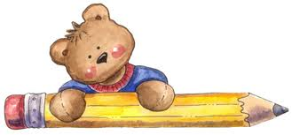

*PLEASE ONLY LABEL THE CHANGE OF CLOTHES AND REST TOWEL.*
We will label all other supplies as needed. Thank you.

